Evaluating the direct, indirect and population-level effects of Long-lasting insecticidal nets (LLINs) across transmission intensities

Background
Malaria control has made substantial gains over the past two decades, largely due to the scale-up of long-lasting insecticidal nets (LLINs). Between 2000 and 2015, LLINs was found to have contributed 68% of the 663 million clinical cases averted by malaria interventions in endemic Africa, where LLIN is the dominant vector control intervention [1,2]. Over the last two decades, mass distribution campaigns have resulted in high levels of population coverage, reflecting the central role of nets in current malaria prevention strategies. LLINs are widely regarded as among the most cost-effective public health interventions against malaria [3]. Their effectiveness arises from two complementary mechanisms: physical prevention of mosquito bites and the insecticidal action that kills or deters mosquitoes. Individuals sleeping under intact, treated nets benefit from direct personal protection, while populations benefit from indirect protection through reductions in mosquito density, survival, and infectivity. This population-level indirect (community) protection means that individuals who do not themselves use nets may nonetheless experience reduced malaria risk when net coverage in the population is high [4–8]. For example, in infectious diseases...
Evidence for the community-level protection of insecticide-treated nets has been demonstrated across multiple modelling and empirical studies, most notably from western Kenya, where reductions in malaria prevalence and child mortality were observed not only among net users but also among non-users living near households using nets [9]. Community-level reductions in malaria prevalence and morbidity have been observed not only among net users but also among non-users living in areas with high net coverage, highlighting the importance of indirect protection [5–7,9,10]. Systematic syntheses of these findings confirm that community effects contribute substantially to the overall impact of LLINs, particularly once coverage exceeds moderate levels [8]. Mechanistic and transmission modelling studies further show that indirect protection can account for a large share of malaria reduction at the population level, often exceeding the contribution of direct personal protection as coverage increases [11]. Recognition of these indirect effects motivated a shift in malaria control policy from targeted net distribution toward universal coverage strategies [12]. By extending protection to all age groups, including adults who contribute to onward transmission, universal coverage aims to maximize both direct and population-level benefits. Modelling work indicates that once population coverage reaches intermediate levels, additional gains in protection increasingly accrue through indirect effects rather than direct personal protection, with transmission declining rapidly before slowing down as the effect of increased coverage approaches saturation [8].
Despite this conceptual foundation, the magnitude and reliability of community protection from LLINs remain under-explored across epidemiological contexts. A growing body of work indicates that indirect effects are heterogeneous and sensitive to local transmission dynamics, intervention coverage, and vector ecology. Recent re-analyses of cluster-randomized trials of malaria interventions such as chemoprevention and/or indoor residual spraying have demonstrated substantial spillover effects on incidence and prevalence among non-recipients, but also highlighted that such effects vary with spatial scale, baseline transmission intensity, and intervention mix [10]. These findings raise important questions about the extent to which community protection can be assumed to scale uniformly with LLIN usage across different transmission settings. Transmission intensity, often summarized by the entomological inoculation rate (EIR), is likely to be a critical determinant of community-level effects as it ranges from <1 to >1000 ib/person/year in the endemic African region. This indicates a wide heterogeneity between countries. Modelling studies parameterized with entomological and epidemiological data have shown that baseline transmission intensity and intervention coverage exert stronger influence on population-level impact than insecticide resistance alone [3].
At high transmission intensity, persistent exposure to infectious bites may constrain the degree to which reductions in mosquito survival translate into meaningful reductions in human infection prevalence, potentially leading to saturation of indirect effects even at high LLIN usage. At the same time, the mechanisms underpinning community protection are evolving. Widespread pyrethroid resistance and declining durability of nets under field conditions have reduced the historical effects of LLINs on mosquitoes, shifting the balance of benefit increasingly toward physical barrier effects and consistent population-level use. Recent syntheses argue that while LLINs remain epidemiologically valuable, their capacity to generate strong communal benefits through mosquito killing has weakened in many settings, particularly where resistance is intense and nets age rapidly [4,13].
Taken together, this raises a critical concern that while community protection is widely used as a justification for universal LLIN coverage, its dependence on transmission intensity and achievable coverage levels has not been systematically quantified across a broad EIR range. Specifically, existing studies rarely quantify how much LLIN usage is required to achieve meaningful reductions in malaria prevalence among non-users, or whether such coverage thresholds remain attainable in high-transmission settings. This therefore motivates analyses that vary EIR independently of specific geographic settings.
In this study, we use a transmission-dynamic malaria model to quantify direct and indirect effects of LLIN usage across a wide range of transmission intensities. We compare malaria prevalence among LLIN users, non-users, and the overall population under varying usage levels, and explicitly estimate these effects as reductions in prevalence among the population groups. We further identify LLIN usage thresholds required to achieve predefined levels of prevalence reduction among non-users. By characterizing how indirect effects emerge, scale, and saturate across transmission settings, this analysis quantifies the conditions under which LLIN-mediated community protection can be expected to occur, and where its effectiveness is inherently constrained.

Methods

Simulation model
OpenMalaria is an individual-based model used to simulate the dynamics of malaria transmission and epidemiology, and the impact of interventions on health and economic outcomes. It is a stochastic open-source platform initially designed for modeling malaria vaccines [14,15]. The model simulates various aspects, including the dynamics of malaria parasitemia during infection, the life cycle of mosquitoes, disease transmission between humans and mosquitoes, the development of anti-malaria immunity in human hosts [16], and the progression to illness and mortality. It captures heterogeneity in exposure, infection, and clinical outcomes across age groups. It has been used extensively to investigate multiple questions relating to disease dynamics or the use of existing and new interventions [17–20]. Detailed description of the model and its parameterization has been done elsewhere [21–23].

Simulation process
We used OpenMalaria (version 44.0) [20] to explore how changes in LLIN usage impact malaria burden across different transmission intensities. We distinguished between direct (personal) protection among LLIN users, indirect (community) protection experienced by non-users due to reduced transmission, and overall protection, which reflects the combined effect across the entire population. Simulations were set up using the OpenMalariaUtilities R package [24]. Starting from the characteristics of the Nkwanta South district in Ghana in terms of demographic structure [25], seasonal transmission patterns [cite], dominant vector species composition [cite], and health system access [26], we generated a suite of hypothetical malaria transmission settings. EIR is a widely used measure of malaria transmission intensity, with empirical estimates in African endemic settings ranging from <1 to several hundred infectious bites per person per year (ib/person/year) [27,28]. Low (<8), intermediate (8–32) and high (>32) regimes have been encountered in modelling work [7,29]. EIR was varied across a range of values to explore LLIN impact. We simulated the model for yearly EIR from 2 to 100, representing ${PfPR}_{0-100}$ levels between [0.12-0.5]. We further categorized the EIR range into low (<8), representing ${PfPR}_{0-100}$ levels between [0.12-0.34], moderate (8–32), representing ${PfPR}_{0-100}$ levels between [0.38-0.46], and high (>32), representing ${PfPR}_{0-100}$ levels between [0.47-0.5] transmission intensity groups, and outcomes were averaged within each category. This range allows assessment of the robustness of LLIN effects across realistic epidemiological settings relevant for most endemic contexts in sub-Saharan Africa.
Within OpenMalaria, bed nets act by modifying parameters of the mosquito feeding cycle model. They reduce host availability, decrease the probability of successful blood feeding following host contact, and reduce the probability that a mosquito successfully finds a resting place after feeding [30].
We further investigated personal vs community protections of the eave ribbon and the push-pull system as well as their interplay with ITNs by tracking incidence per cohort of people with respect to access to ITNs and either of the new interventions
In Openmalaria, a cohort is a sub-population which can be monitored separately and can be used to target intervention deployment [OM Wiki]
LLIN exposure was defined by usage rather than net ownership or treated versus untreated nets. At the individual level, LLIN usage represented the probability that a person sleeps under an LLIN on a given night. LLIN usage was varied from 0% to 90% at the population level, allowing users and non-users to coexist within the same simulated population such that 20% LLIN usage implies that 20% of the population sleep under a net after mass campaign distribution and the rest (80%) of the population become non-users. Importantly, one LLIN type, chlorfenapyr-pyrethroid net (Interceptor®G2) was considered in this study and the analysis focused on usage-driven protection rather than differences in net type or insecticidal decay. The simulated population was stratified by LLIN usage status and three different age groups (0-5, 0-10 and the full age range, 0-100 years). At each level of LLIN usage coverage, individuals were categorised as either LLIN users or LLIN non-users. This stratification enabled separate estimation of malaria prevalence among users and non-users while preserving shared exposure to the same transmission environment.
The model was run over 35 years. Before 2000, the model is assumed to be at equilibrium. Simulations were initiated with only case management implemented in the model as intervention from 2003 to 2022. Starting in 2023, campaign distribution of LLIN was implemented in the years 2023, 2026 and 2029, assuming a 3-year net distribution cycle. No other intervention was added from 2023 in order to isolate the impact of the LLINs. In a population of 10’000, each scenario was simulated 10 times and ran up to the year 2035. To reproduce rapid diagnostic test detection limit, parasite detection limit was set at 100 parasites per microliter in the model [31]. All LLIN effects were quantified relative to a counterfactual baseline scenario in which LLIN usage was set to zero, to imply no LLIN usage across the population. The prevalence observed among non-users in this baseline scenario was used as the reference prevalence for estimating both direct and indirect effects. This choice ensured that all effect estimates were anchored to a consistent, no LLIN transmission context.
Effect definitions and estimates
The primary outcome was malaria prevalence ($PfPR$), measured as the proportion of individuals in the population with patent infection. Using prevalence as the outcome allowed direct comparison of infection burden across users, non-users, and the total population. We defined three complementary measures of LLIN impact. We let $c$represent LLIN usage level, x represent age group, ${PfPR}_{Users}(c)$ represent prevalence among LLIN users at LLIN usage level $c$, ${PfPR}_{Non-users}(c)$ represent prevalence among non-users at LLIN usage level $c$ and ${PfPR}_{baseline}$ represent the counterfactual baseline prevalence defined as prevalence among non-users in simulations without LLIN usage (LLIN usage = 0). Direct protection was defined as the reduction in malaria prevalence among LLIN users compared to the counterfactual baseline prevalence. We subtract the average of prevalence over the three-year distribution cycle from the counterfactual baseline, so we obtain the reduction in prevalence due to the intervention: ${Direct Protection}_{x}(c)=100*({PfPR}_{baseline}-{PfPR}_{Users}\left(c\right))$. Indirect protection was defined as the reduction in malaria prevalence among LLIN non-users compared to the counterfactual baseline prevalence, capturing benefits mediated through reduced community-level transmission: ${Indirect Protection}_{\text{x}}\left(c\right)=100*({PfPR}_{baseline}-{PfPR}_{Non-users})$. Because LLIN usage in this analysis was set up to 90%, LLIN users and non-users coexisted in all simulated scenarios where LLINs were deployed. This allowed population-level transmission effects to be distinguished from direct individual-level protection. The Overall protection (total population-level benefit of LLIN usage at coverage $c$ ) was defined as the reduction in malaria prevalence relative to the counterfactual baseline. For each LLIN usage level, population-level malaria prevalence was calculated by aggregating the number of patent infections and hosts across LLIN users and non-users. Specifically, the total number of patent infections and the total number of hosts contributing to prevalence were summed across usage strata, and population prevalence was computed as the ratio of these aggregated quantities. Then Overall protection was computed as ${Overall Protection}_{x}\left(c\right)=100*({PfPR}_{baseline}-{PfPR}_{Population}\left(c\right))$.
We also calculated how far the overall reduction at the population level deviates from what LLIN users experience, as the difference between prevalence reduction among the population and LLIN users:
$$CE\left(c\right)={Overall Protection}_{x}\left(c\right)-{Direct Protection}_{x}\left(c\right)$$
$$CE=\left(c\right)=100*{(PfPR}_{baseline}-{PfPR}_{Population}\left(c\right))-100*\left({PfPR}_{baseline}-{PfPR}_{Users}\left(c\right)\right)$$
$$=100*({PfPR}_{Users}(c)-{PfPR}_{Population}\left(c\right))$$
This metric was calculated such that declining values with increasing coverage indicate convergence between user-level and population-level impact as LLIN usage becomes more widespread.
Coverage threshold estimation
To quantify the level of LLIN usage required to achieve predefined epidemiological targets, we estimated coverage thresholds corresponding to 10% and 20% reductions in malaria prevalence among non-users (i.e., the indirect or community effect). Prevalence was averaged over the evaluation period (2026–2028), representing one LLIN distribution cycle. Within each EIR category, prevalence reduction curves were constructed as a function of LLIN usage. Prevalence reductions were first calculated at each individual EIR level, and category-level curves were then obtained by averaging reductions across EIR values within each category at each coverage level. Coverage thresholds were estimated using linear interpolation. For each EIR category, the LLIN usage required to achieve 10% and 20% prevalence reduction among non-users was obtained by interpolating the coverage value corresponding to these target reduction levels along the category-averaged reduction curve. Interpolation was performed using a piecewise linear approximation of the empirical coverage–reduction relationship. These thresholds therefore represent the estimated LLIN usage required to achieve predefined levels of indirect protection within each transmission intensity category.

Analysis focus
All analyses were conducted in R (version 4.2.1 (2022-06-23)). Simulation outputs were aggregated by EIR category, LLIN usage, and population group. Analyses focused on three key dimensions:
- The relationship between malaria prevalence and LLIN usage coverage.
- The magnitude of indirect effects experienced by non-users as coverage increased.
- Identification of coverage thresholds, with particular attention to usage levels of 10% and 20%, at which indirect protection became detectable.
Results were summarised across transmission intensity levels to characterise how direct and indirect effects vary with baseline transmission.

Conceptual framework
A conceptual flow diagram was developed to summarise the modelling framework, illustrating the progression from model parameterisation and transmission intensity scenarios to LLIN usage, population stratification, counterfactual comparison, and estimation of direct, indirect, overall protection and community effects (Figure 1).
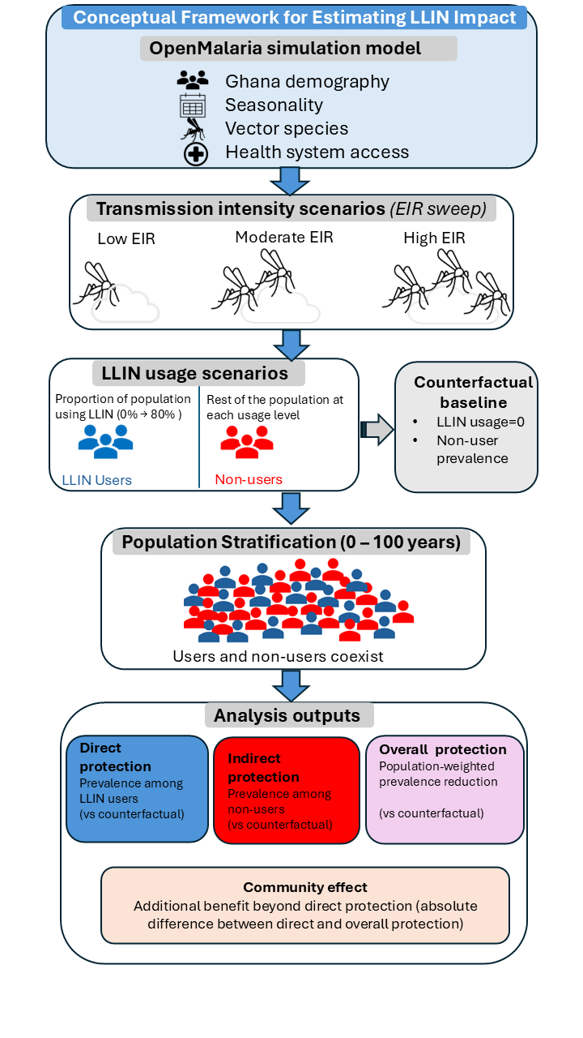
Figure 1: Conceptual framework for estimating direct, indirect, and population-level effects of LLIN usage across transmission intensities. The OpenMalaria simulation model incorporates Ghana demography, seasonality, vector species composition, and health system access to simulate malaria transmission. Transmission intensity scenarios are defined through an entomological inoculation rate (EIR) sweep (low, moderate, and high). For each transmission setting, LLIN usage scenarios vary the proportion of the population using LLINs, generating distinct user and non-user groups. Individuals are stratified across ages (0–100 years), with users and non-users coexisting within the same simulated population. Outcomes include (i) direct protection, defined as prevalence reduction among LLIN users relative to a counterfactual baseline (LLIN usage = 0); (ii) indirect protection, defined as prevalence reduction among non-users relative to the same baseline; and (iii) overall protection, defined as population-weighted prevalence reduction. The community effect represents the additional population-level benefit beyond direct protection.

Results
Transmission intensity modifies temporal trends in malaria prevalence
Temporal trends for two LLIN distribution cycles (in 2024 and 2027) indicated that malaria prevalence declined over time with increasing LLIN usage across all transmission intensities (EIR), with the steepest declines observed shortly after intervention deployment (Figure 2). At low transmission intensity (EIR = 8), prevalence declined rapidly following LLIN deployment, with marked reductions observed among both LLIN users and non-users. At moderate transmission intensity (EIR = 32), prevalence declined more gradually and remained higher throughout the study period. At high transmission intensity (EIR = 100), prevalence remained substantial over time even at high LLIN usage, particularly among non-users.
Across all EIRs and LLIN usage levels, prevalence was consistently lower among LLIN users than among non-users, reflecting the direct protective effect of LLIN use (Figure 2). However, declining prevalence among non-users as LLIN usage increased indicates the presence of indirect, community-level protection, the strength of which diminished with increasing transmission intensity.

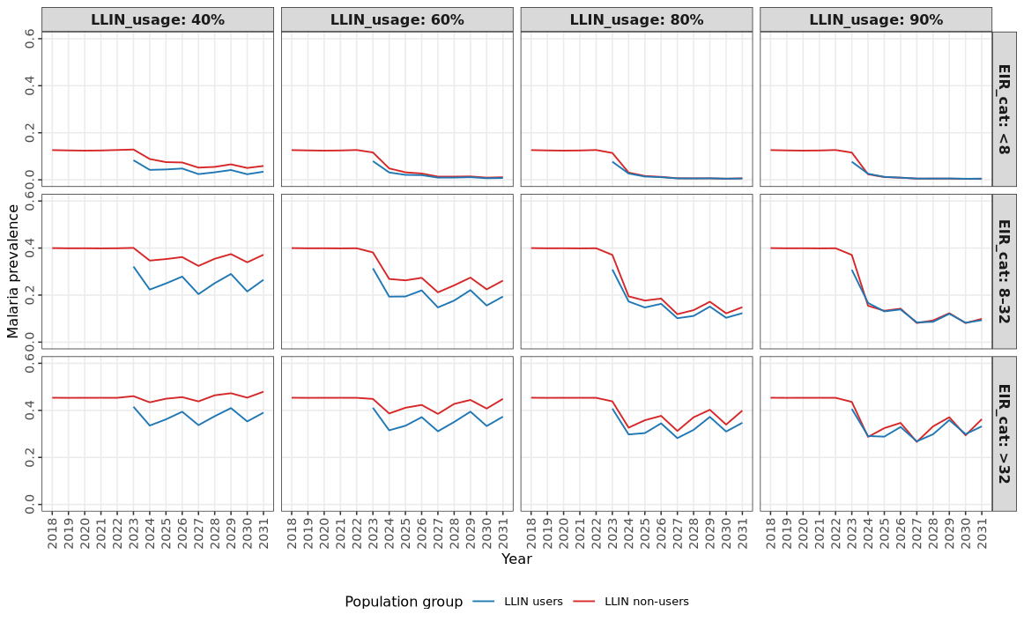
Figure 2: Temporal trends in malaria prevalence among LLIN users and non-users across transmission intensity levels. Malaria prevalence from 2024–2029 is shown for LLIN users and non-users under varying LLIN usage levels and entomological inoculation rate categories (Low, Moderate, High). Rows correspond to increasing transmission intensity, and columns correspond to increasing LLIN usage.
An increase in LLIN usage leads to a decline in prevalence among all population groups, across transmission intensity levels
All-age / u5 malaria prevalence declined monotonically with increasing LLIN usage among LLIN users, non-users, and the overall population (Figure 3). LLIN users consistently experienced the lowest prevalence, reflecting the direct protective effect of LLIN use. Prevalence among non-users also declined as LLIN usage increased, indicating the presence of indirect (community-level) effect of LLIN use.
Overall-population prevalence closely tracked prevalence among non-users across all transmission intensities (Figure 3), indicating that indirect effects contribute substantially to overall population-level impact. The gap between users and non-users narrowed as LLIN usage increased, particularly at low transmission intensity, but remained pronounced at high transmission intensity.

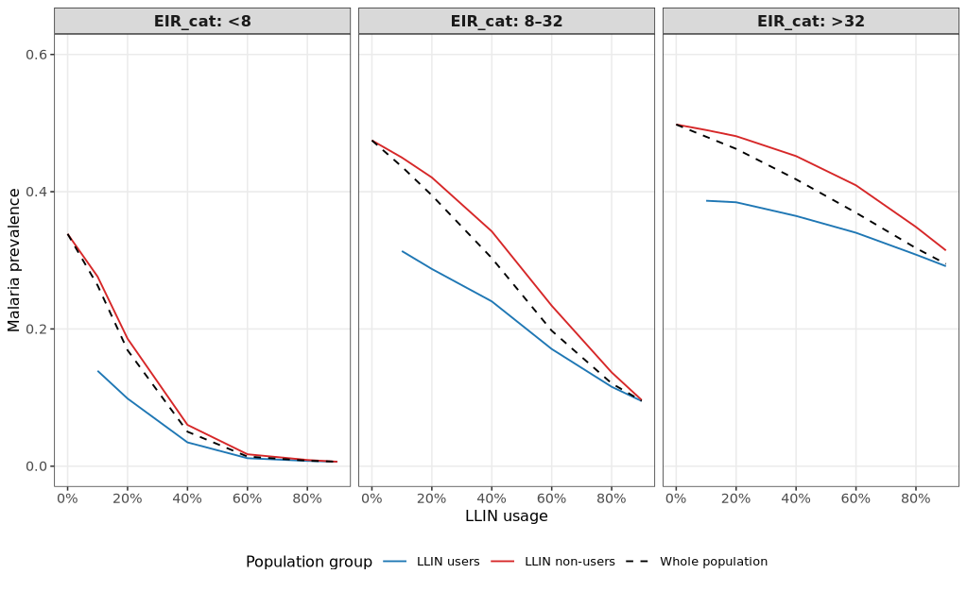
Figure 3: Malaria prevalence among LLIN users, non-users, and the overall population as a function of LLIN usage. Mean malaria prevalence is shown as a function of LLIN usage for LLIN users, non-users, and the overall population across transmission intensity levels. LLIN users consistently experience the lowest prevalence, while non-users benefit indirectly as LLIN usage increases. Overall-population prevalence closely tracks prevalence among non-users, indicating that indirect effects contribute substantially to population-level impact.

Prevalence reduction varied by transmission intensity
At 60% LLIN usage, prevalence reduction varied by transmission intensity. In low transmission settings (EIR <8), prevalence reduction was similar across groups, reaching approximately 33% among users and 32% among non-users, reflecting strong community-wide suppression (Fig below). In intermediate transmission settings (EIR 8–32), reductions were 30% among users, 24% among non-users, and 27% in the total population, indicating attenuation of indirect protection relative to direct protection. In high transmission settings (EIR >32), reductions were lower, reaching 15% among users and 9% among non-users, consistent with diminished community-level impact under intense transmission pressure. Interquartile ranges across 10 stochastic simulations were narrow, indicating stable estimates.
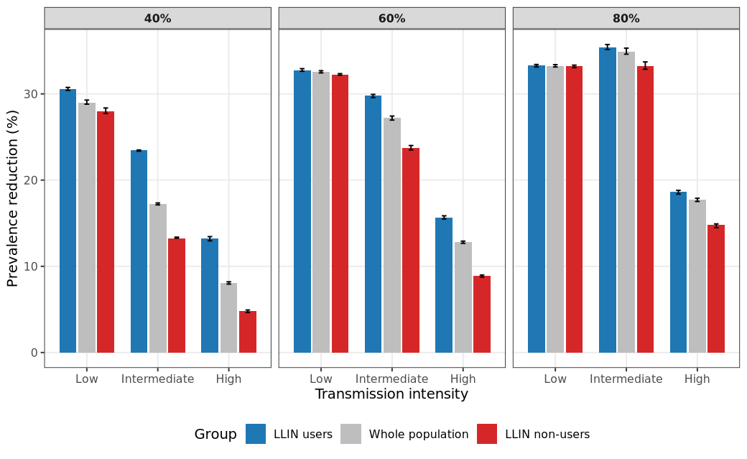
Community-level prevalence reduction scales non-linearly with LLIN usage
Direct and indirect effects of LLINs were quantified as reductions in prevalence among users and non-users respectively, relative to the no-LLIN baseline. Community effect was also quantified as the difference in prevalence reduction between LLIN users and the overall population.
Reductions in malaria prevalence relative to the no-LLIN baseline increased with LLIN usage for all population groups but exhibited strong non-linearities (Figure 4). Among LLIN users, prevalence reduction increased steadily with LLIN usage across all transmission intensities. Among non-users, prevalence reduction increased more slowly at low coverage and accelerated at higher LLIN usage, consistent with the emergence of community-level protection.
At low transmission intensity (EIR = 8), substantial community-level prevalence reductions were achieved at relatively modest LLIN usage. At moderate transmission intensity (EIR = 32), higher LLIN usage was required to generate comparable reductions. At high transmission intensity (EIR = 100), prevalence reductions among non-users remained modest even at high LLIN usage, indicating saturation of indirect effects (Figure 4).
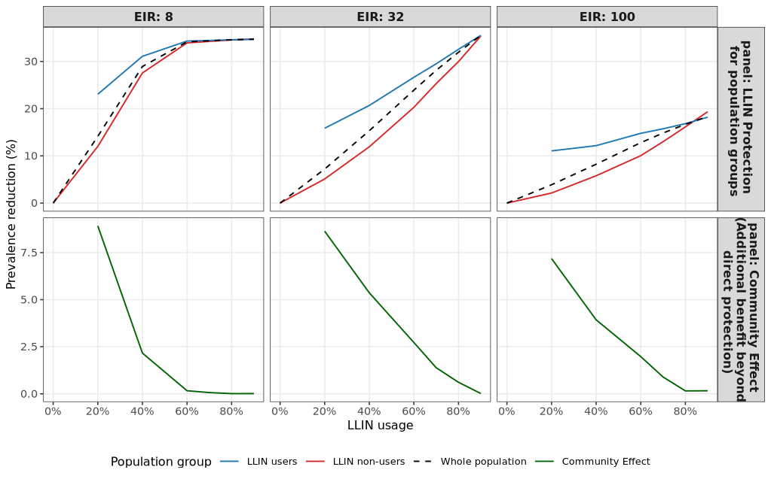
Figure 4: Prevalence reduction among LLIN users, non-users, and the overall population across LLIN usage levels. Percentage reduction in malaria prevalence relative to the no-LLIN baseline is shown for LLIN users, non-users, and the overall population across increasing LLIN usage. Community effect, measured as the difference in prevalence reduction between the overall population and LLIN users, increases non-linearly with LLIN usage and is strongest at low transmission intensity. At high transmission intensity, community-level reductions remain modest even at high LLIN usage.

The magnitude of indirect protection varied continuously across transmission intensities (Figure X). At low EIR (<20), increasing LLIN coverage from 40% to 80% resulted in substantial reductions in prevalence among non-users, reaching up to 35–40%. In contrast, at high EIR (>80), the same increase in coverage yielded markedly smaller gains. The relationship between coverage and indirect protection was nonlinear, with steep increases observed at moderate coverage levels and evidence of diminishing returns at very high transmission intensity.
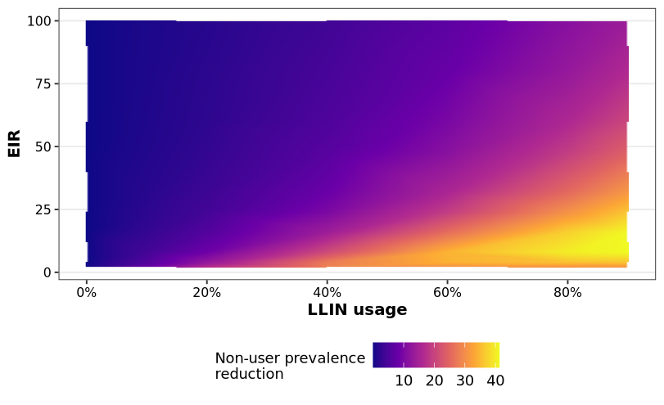
LLIN usage thresholds for community protection increase with transmission intensity
Coverage thresholds were estimated separately for each seed by linearly interpolating the LLIN usage required to achieve 10% and 20% prevalence reduction among non-users.
The LLIN usage required to achieve predefined community-level prevalence reduction targets increased monotonically with transmission intensity (Figure 5). At low transmission intensity, LLIN usage below 30% was sufficient to achieve a 10% reduction in prevalence among non-users, whereas substantially higher usage was required at moderate transmission intensity. At high transmission intensity, achieving a 20% reduction among non-users required near-universal LLIN usage, and in some cases was not achievable within the explored coverage range.
Across all transmission intensities, the increase in required LLIN usage between the 10% and 20% reduction thresholds was substantial (Figure 5), highlighting diminishing marginal returns of increasing coverage in high-transmission settings.
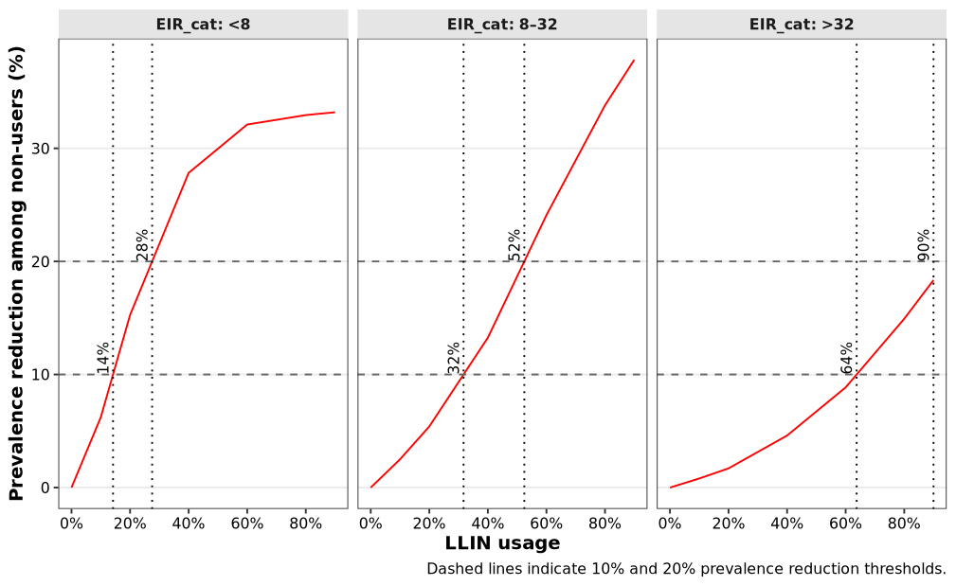
Figure 5: LLIN usage required to achieve non-user prevalence reduction thresholds.
The relationship between LLIN usage and prevalence reduction among non-users is shown for transmission intensity levels. Horizontal dashed lines indicate 10% and 20% prevalence reduction thresholds, and vertical dotted lines indicate the LLIN usage required to achieve these thresholds. Required LLIN usage increases monotonically with transmission intensity, reaching near-universal coverage levels at high EIR levels.
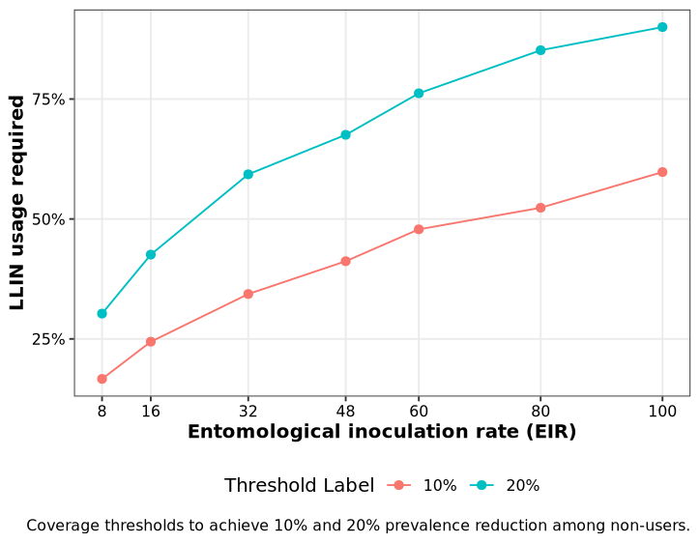
Figure 6: (supplementary – update with new simulation outputs)

Discussion
Existing modelling studies show that indirect effects can dominate population-level impact as coverage increases. Our results show that this dominance is conditional on transmission intensity, and that at high EIR the contribution of indirect protection saturates and may no longer exceed direct effects.

Conclusion
LLINs generate strong community-level suppression in low-to-moderate transmission settings but act primarily as individual protection tools in high-transmission areas, implying that transmission-stratified coverage targets and layered intervention strategies are essential for efficient malaria control

References
1. Bhatt S, Weiss DJ, Cameron E, Bisanzio D, Mappin B, Dalrymple U, et al. The effect of malaria control on Plasmodium falciparum in Africa between 2000 and 2015. Nature. 2015;526:207–11. https://doi.org/10.1038/nature15535
2. Raghavendra K, Barik TK, Reddy BPN, Sharma P, Dash AP. Malaria vector control: from past to future. Parasitol Res. 2011;108:757–79. https://doi.org/10.1007/s00436-010-2232-0
3. Briët OJT, Penny MA, Hardy D, Awolola TS, Van Bortel W, Corbel V, et al. Effects of pyrethroid resistance on the cost effectiveness of a mass distribution of long-lasting insecticidal nets: a modelling study. Malar J. 2013;12:77. https://doi.org/10.1186/1475-2875-12-77
4. Okumu F. The fabric of life: what if mosquito nets were durable and widely available but insecticide-free? Malar J. 2020;19:260. https://doi.org/10.1186/s12936-020-03321-6
5. Killeen GF, Okumu FO, N’Guessan R, Coosemans M, Adeogun A, Awolola S, et al. The importance of considering community-level effects when selecting insecticidal malaria vector products. Parasit Vectors. 2011;4:160. https://doi.org/10.1186/1756-3305-4-160
6. Lukole EA, Cook J, Mosha JF, Matowo NS, Kulkarni MA, Mallya E, et al. Community benefits of mass distribution of three types of dual-active-ingredient long-lasting insecticidal nets against malaria prevalence in Tanzania: evidence from a 3-year cluster-randomized controlled trial. BMC Public Health. 2025;25:346. https://doi.org/10.1186/s12889-025-21586-x
7. Unwin HJT, Sherrard-Smith E, Churcher TS, Ghani AC. Quantifying the direct and indirect protection provided by insecticide treated bed nets against malaria. Nat Commun. 2023;14:676. https://doi.org/10.1038/s41467-023-36356-9
8. Ko YK, Kagaya W, Chan CW, Kanamori M, Mbugua SM, Rotich AK, et al. Unraveling the “community effects” of interventions against malaria endemicity: a systematic scoping review. BMJ Public Health. 2024;2:e001557. https://doi.org/10.1136/bmjph-2024-001557
9. Lindblade KA, Dotson E, Hawley WA, Bayoh N, Williamson J, Mount D, et al. Evaluation of long-lasting insecticidal nets after 2 years of household use. Trop Med Int Health TM IH. 2005;10:1141–50. https://doi.org/10.1111/j.1365-3156.2005.01501.x
10. Benjamin-Chung J, Li H, Nguyen A, Barratt Heitmann G, Bennett A, Ntuku H, et al. Extension of efficacy range for targeted malaria-elimination interventions due to spillover effects. Nat Med. 2024;30:2813–20. https://doi.org/10.1038/s41591-024-03134-z
11. Killeen GF, Smith TA. Exploring the contributions of bed nets, cattle, insecticides and excitorepellency to malaria control: a deterministic model of mosquito host-seeking behaviour and mortality. Trans R Soc Trop Med Hyg. 2007;101:867–80. https://doi.org/10.1016/j.trstmh.2007.04.022
12. Killeen GF, Smith TA, Ferguson HM, Mshinda H, Abdulla S, Lengeler C, et al. Preventing childhood malaria in Africa by protecting adults from mosquitoes with insecticide-treated nets. PLoS Med. 2007;4:e229. https://doi.org/10.1371/journal.pmed.0040229
13. Janko MM, Churcher TS, Emch ME, Meshnick SR. Strengthening long-lasting insecticidal nets effectiveness monitoring using retrospective analysis of cross-sectional, population-based surveys across sub-Saharan Africa. Sci Rep. 2018;8:17110. https://doi.org/10.1038/s41598-018-35353-z
14. Smith T, Ross A, Maire N, Chitnis N, Studer A, Hardy D, et al. Ensemble Modeling of the Likely Public Health Impact of a Pre-Erythrocytic Malaria Vaccine. PLOS Med. 2012;9:e1001157. https://doi.org/10.1371/journal.pmed.1001157
15. Smith T, Killeen GF, Maire N, Ross A, Molineaux L, Tediosi F, et al. MATHEMATICAL MODELING OF THE IMPACT OF MALARIA VACCINES ON THE CLINICAL EPIDEMIOLOGY AND NATURAL HISTORY OF PLASMODIUM FALCIPARUM MALARIA: OVERVIEW. Am J Trop Med Hyg. 2006;75:1–10. https://doi.org/10.4269/ajtmh.2006.75.2_suppl.0750001
16. Maire N, Smith T, Ross A, Owusu-Agyei S, Dietz K, Molineaux L. A model for natural immunity to asexual blood stages of Plasmodium falciparum malaria in endemic areas. Am J Trop Med Hyg. 2006;75:19–31. https://doi.org/10.4269/ajtmh.2006.75.19
17. Chitnis N, Smith T, Steketee R. A mathematical model for the dynamics of malaria in mosquitoes feeding on a heterogeneous host population. J Biol Dyn. 2008;2:259–85. https://doi.org/10.1080/17513750701769857
18. Chitnis N, Hardy D, Smith T. A Periodically-Forced Mathematical Model for the Seasonal Dynamics of Malaria in Mosquitoes. Bull Math Biol. 2012;74:1098–124. https://doi.org/10.1007/s11538-011-9710-0
19. Smith T, Killeen GF, Maire N, Ross A, Molineaux L, Tediosi F, et al. Mathematical modeling of the impact of malaria vaccines on the clinical epidemiology and natural history of Plasmodium falciparum malaria: Overview. Am J Trop Med Hyg. 2006;75:1–10. https://doi.org/10.4269/ajtmh.2006.75.2_suppl.0750001
20. OpenMalaria Online wiki [Internet]. GitHub. [cited 2025 Apr 23]. https://github.com/SwissTPH/openmalaria/wiki/Home. Accessed 23 Apr 2025
21. Chitnis N, Smith T, Steketee R. A mathematical model for the dynamics of malaria in mosquitoes feeding on a heterogeneous host population. J Biol Dyn. 2008;2:259–85. https://doi.org/10.1080/17513750701769857
22. Reiker T, Chitnis N, Smith T. Modelling reactive case detection strategies for interrupting transmission of Plasmodium falciparum malaria. Malar J. 2019;18:259. https://doi.org/10.1186/s12936-019-2893-9
23. Smith T, Maire N, Ross A, Penny M, Chitnis N, Schapira A, et al. Towards a comprehensive simulation model of malaria epidemiology and control. Parasitology. 2008;135:1507–16. https://doi.org/10.1017/S0031182008000371
24. Swiss TPH. openMalariaUtilities [Internet]. [cited 2024 Jul 21]. https://github.com/SwissTPH/r-openMalariaUtilities. Accessed 21 Jul 2024
25. NMEP G. National Malaria Elimination Strategic Plan [Internet]. https://mesamalaria.org/resource-hub/national-malaria-elimination-strategic-plan-nmesp-of-ghana-2024-2028/
26. Galactionova K, Tediosi F, Savigny D de, Smith T, Tanner M. Effective Coverage and Systems Effectiveness for Malaria Case Management in Sub-Saharan African Countries. PLOS ONE. 2015;10:e0127818. https://doi.org/10.1371/journal.pone.0127818
27. Beier JC, Killeen GF, Githure JI. Short report: entomologic inoculation rates and Plasmodium falciparum malaria prevalence in Africa. Am J Trop Med Hyg. 1999;61:109–13. https://doi.org/10.4269/ajtmh.1999.61.109
28. Hakizimana E, Karema C, Munyakanage D, Githure J, Mazarati JB, Tongren JE, et al. Spatio-temporal distribution of mosquitoes and risk of malaria infection in Rwanda. Acta Trop. 2018;182:149–57. https://doi.org/10.1016/j.actatropica.2018.02.012
29. Camponovo F, Jeandron A, Skrip LA, Golumbeanu M, Champagne C, Symons TL, et al. Malaria treatment for prevention: a modelling study of the impact of routine case management on malaria prevalence and burden. BMC Infect Dis. 2024;24:1267. https://doi.org/10.1186/s12879-024-09912-x
30. Chitnis N, Schapira A, Smith T, Steketee R. Comparing the effectiveness of malaria vector-control interventions through a mathematical model. Am J Trop Med Hyg. 2010;83:230–40. https://doi.org/10.4269/ajtmh.2010.09-0179
31. Moody A. Rapid Diagnostic Tests for Malaria Parasites. Clin Microbiol Rev. 2002;15:66–78. https://doi.org/10.1128/CMR.15.1.66-78.2002

